# Docker Desktop Installation Guide

Guide for downloading and installing Docker Desktop on Windows, Mac, and Linux   
for the ["Containers and Clouds"](https://softuni.bg/trainings/4359/containers-and-cloud-january-2024) course @ SoftUni.

## **Download Docker Desktop on Windows**

First, you will need to open the Docker documentation <https://docs.docker.com/desktop/>.

Choose **"Windows"** from the menu on the left side of the screen. Before installing make sure that your machine **matches the needed requirements** to use Docker Desktop.

For example, if you use Windows 10+ you could **directly** download and install Docker Desktop because the platform runs natively on Windows 10+:

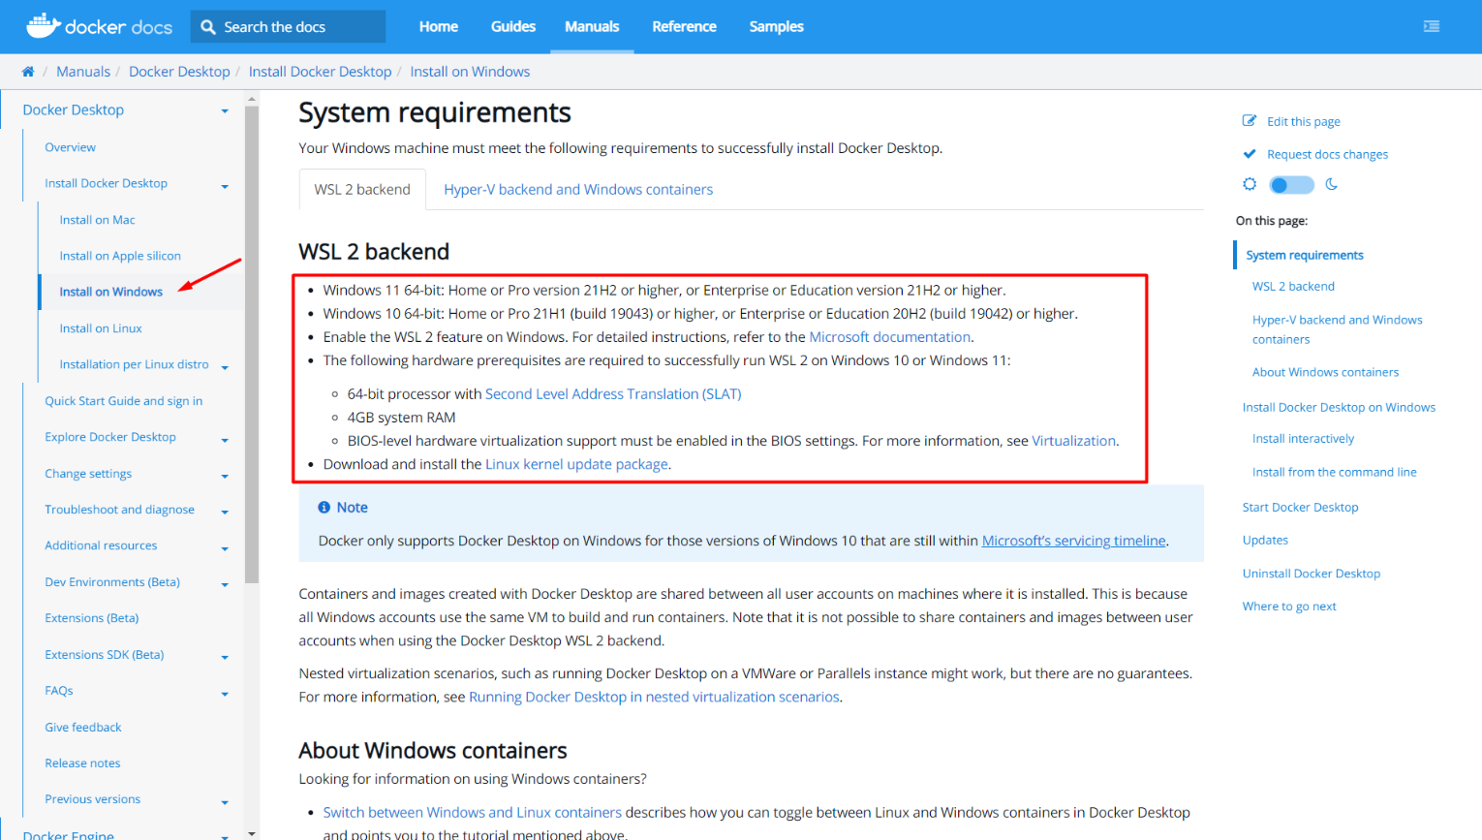

Download the **Docker Desktop Installer**:

**Double-click** **Docker Desktop Installer.exe** to run it (for this example, Docker Desktop 4.10.1 will be installed; you do **NOT** need to download the same version of the software - it would be best to download the newest one).

When prompted, ensure the **"Use WSL 2 instead of Hyper-V"** option on the Configuration page **is selected** or not depending on your choice of backend. If your system only supports one of the two options, you will **NOT** be able to select which backend to use:

The installation could take couple of minutes:

When the installation is successful, click **[Close]** to complete the installation process:

Docker Desktop does **NOT** **start automatically** after installation. To start Docker Desktop **double-click on the "Docker Desktop" icon**. First, it will display the **Docker Subscription Service Agreement** window. Read the terms and click the checkbox to indicate that you accept the updated terms and then click **Accept** to continue:

Docker Desktop starts after you accept the terms. You may see **the following pop-up message**:

If you do - **click on the link**, do **NOT** **close** the pop-up message, and install the **Subsystem for Linux update**:

Congratulations! You are now successfully running Docker Desktop on Windows.

## **Download Docker Desktop on Mac**

First, you will need to open the Docker documentation <https://docs.docker.com/desktop/>.

Choose **"Mac"** from the menu on the left side of the screen. Before installing make sure that your machine **matches the needed requirements** to use Docker Desktop.

For example, if you use MacOS 10.15+ you could **directly** download and install Docker Desktop:

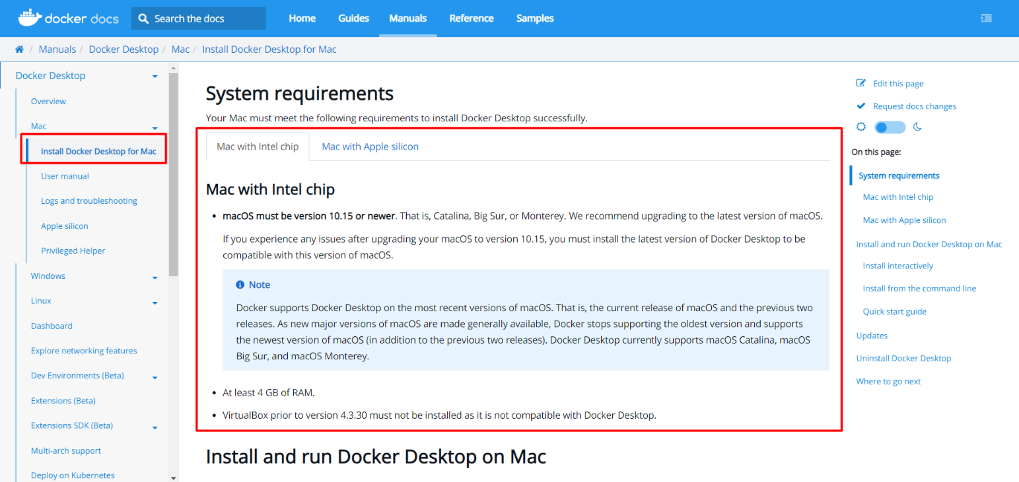

Download the **Docker Desktop Installer**:

**Double-click Docker.dmg** to open the installer, then **drag the Docker icon to the Applications folder**:

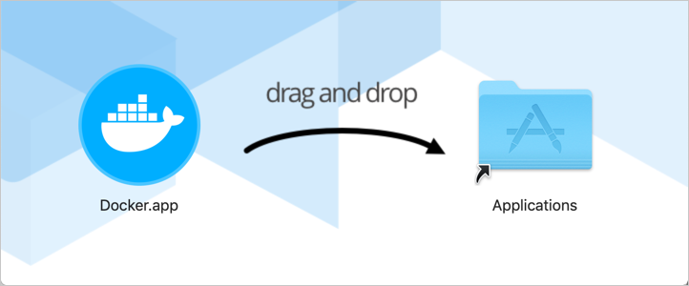

**Double-click Docker.app** in the Applications folder to start Docker.

First, it will display the **Docker Subscription Service Agreement** window. Read the terms and click the checkbox to indicate that you accept the updated terms and then click **Accept** to continue:

Congratulations! You are now successfully running Docker Desktop on Mac.

## **Download Docker Desktop on Linux**

First, you will need to open the Docker documentation <https://docs.docker.com/desktop/>.

Choose **"Linux"** from the menu on the left side of the screen. Before installing make sure that your machine **matches the needed requirements** to use Docker Desktop.

For example, your Linux distribution should have 64-bit kernel and CPU support for virtualization, KVM virtualization support, and QEMU must be version 5.2 or newer:

Download the correct package **for your Linux distribution** and **install** it with the **corresponding package manager**:

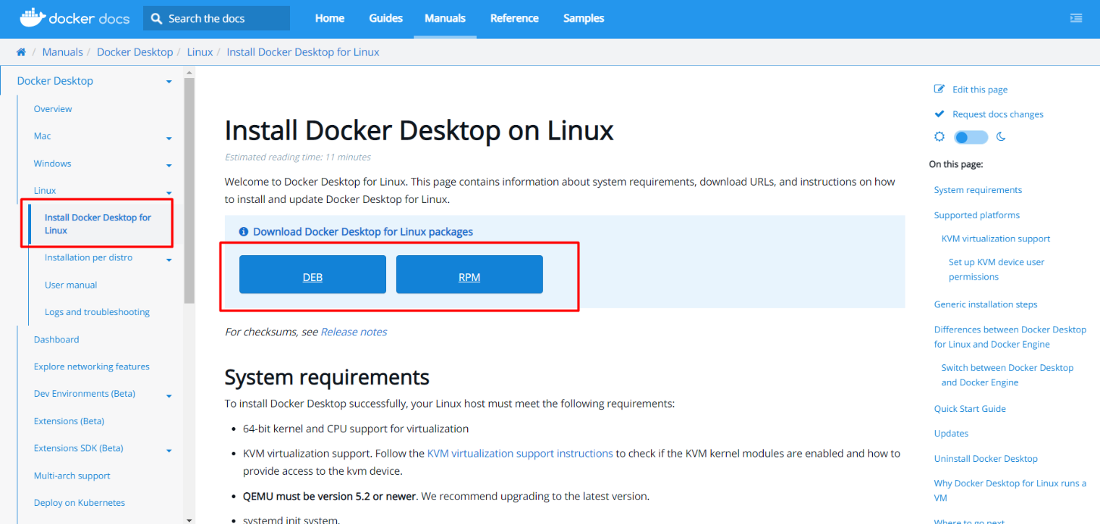

* More on how to install Docker Desktop on **Debian**: <https://docs.docker.com/desktop/linux/install/debian/>
* More on how to install Docker Desktop on **Fedora**: <https://docs.docker.com/desktop/linux/install/fedora/>
* More on how to install Docker Desktop on **Ubuntu**: <https://docs.docker.com/desktop/linux/install/ubuntu/>
* More on how to install Docker Desktop on **Arch**: <https://docs.docker.com/desktop/linux/install/archlinux/>

**Open your Applications menu in Gnome/KDE Desktop and search for Docker Desktop. Then, select Docker Desktop to start Docker**.

First, it will display the **Docker Subscription Service Agreement** window. Read the terms and click the checkbox to indicate that you accept the updated terms and then click **Accept** to continue:

If you installed it **correctly**, you should see the following window:

Congratulations! You are now successfully running Docker Desktop on Linux.